Overview :
Plot
3 heroes went on a quest to save the town of Hallowford from the warden, but 20 years later, the warden is back and causing cursed magic in the town once again. The player, an 18-year-old son of one of the previous heroes, finds himself in the heart of the chaos and has the choice to stand up for the town like his father once did or run and watch the town his father once risked his life to defend crumble.
Win/lose conditions:
Win
- Surviving (defeating the warden or running)
lose
- Dying at any point

Player :
The player is Rowan Saltwhistle, son of Seamus Saltwhistle (previous town hero) and Isla Saltwhistle. Rowan grew up in Hallowford, and has the choice to fight or leave.
Actions:
- look around
- pick up / drop items
- explore the environment (doors, bridges, pathways)
- search items (chests, cabinets, bodies)
- Fight (undecided mechanics)
Limitations:
- Not invincible (affected by damage taken)
- Powers unknown, can be discovered though
- Weight limit, can carry everything
- Amount of stuff on the player affects how effective they can act. (a lot of clanky armor = less stealth)

Scoring :
How to gain points:
- Making advancements through the story
- Defeating enemies, depending on how easily done
- Picking up important items
Losing points:
- Taking damage
- Letting npc’s die
- Making wrong decisions
Max points: Undecided

The World :
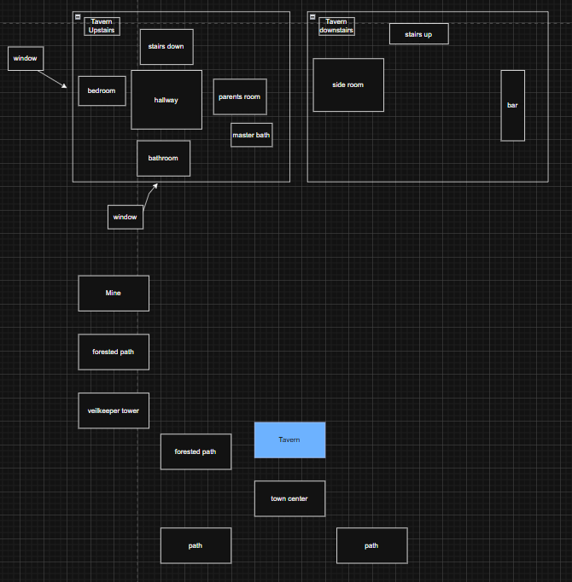
Rooms:
Tavern:
Bedroom
- Where the player starts, woken up by banging at the door
  - Dresser
  - Nightstand in northwest
    - Knife on top
    - Drawer on inside
  - Door to east
  - Window to west

Hallway
- Just a hallway with 3 doors and staircase
  - Can go to doors or staircase

Parents’ bedroom
- Pristine, parent have already woken up an gotten ready
  - Can explore, loot drawers and such

Bathroom
- can loot, looks like a bathroom

Main tavern
- people, bar, tables

Non-Player Characters (NPCs) :
Dad, Mom, people in bar

